

electronic Customs management system
User Guide

On

International Transit dECLARATION- CFA

Version: 1.0
Date: 05/09/2022

About Yang Khor Pvt Ltd

Yang Khor IT Solutions is a leading In-country Technology Solutions Provider providing solution in terms of hardware, software, support, and services as its complete package.
Yang Khor IT Solutions has been serving its purpose since 2005, it now has emerged to be an unprecedented leader as a Solution Integrator with a differentiated vertical approach to providing innovative solutions. Yang Khor uses its solution integration capabilities to integrate best-of-breed products through its key technology alliance partners to provide “End to End” solutions. Provide customized business solutions that help organizations accelerate revenue growth, increase market penetration, optimize operating costs and improve employee productivity, by embedding communication in their business processes.

Yang Khor IT Solutions has achieved to be the Gold Partner of HPE, Service One Partner of HPE, Microsoft Silver Partner and VMWARE Professional Partner and having this Partnership we are able to serve the best of solution to our clients. Yang Khor IT Solution initially focuses on providing the best solution in terms of hardware and software, to serve the purpose of making life better with the Advance Technology which the world is moving forward with.

DOCUMENT HISTORY
S.No | Date | Version. No | Description | Approved By
1 | 05/09/2022 | 1.0 | First Release

Contents
- A. Chapter 1- About This Guide 4
Purpose and Audience 4
Document Conventions 4
- B. Chapter 2- Getting Started 5
End-user experience of the self-service process 5
1. Logging In 5
1.1. Forgot/Reset password? 7
- C. Chapter 3- Create Road Manifest. 10
D. To Create Road Manifest 10
B. Search Road Manifest 14
C. Cancel Road Manifest 16
- Chapter 4- Logging Out 17

Chapter 1- About This Guide
Welcome to the Trade Facilitation Baseline Customs Management System (eCMS) user guide for CFA USER! This user guide aims to enumerate the process and steps involved in using eCMS.
This user guide is divided into different topics and sub-topics. Each topic discusses and shows the steps of the modules that the eCMS.

Purpose and Audience
This user guide will help the user to get a quick reference on usage of the system.

Document Conventions
Refer to this section to familiarise yourself with the visual aids used throughout the user guide.
Navigation
To assist you with accessing screens, pages, or windows, refer to the following navigation format:
Click User Registration>>Users
Buttons, fields, and other system elements
All system elements are highlighted in Bold text.
Hyperlinks
All topics mentioned in the user guide’s content are hyperlinked. Click on the hyperlink to view the referenced topic.
Callouts
Callouts are presented differently from the original CONTENTS and highlight certain information.
There are two types of callouts: tips and warnings.

@ | A Tip provides useful information that helps you complete a task or procedure.

! | A Warning refers to information that may be critical to the system’s functionality and might affect data or system stability.

Chapter 2- Getting Started
Refer to this chapter to familiarize yourself with the eCMS System; how to log in and log off from the system.

End-user experience of the self-service process

Logging In
To log in to the eCMS:
- Type in URL http://uat.ecms.gov.bt/ECMSFE/login/indexBhutan.jsp in your Internet browser to access the eCMS System.
- eCMS Front End landing page will display

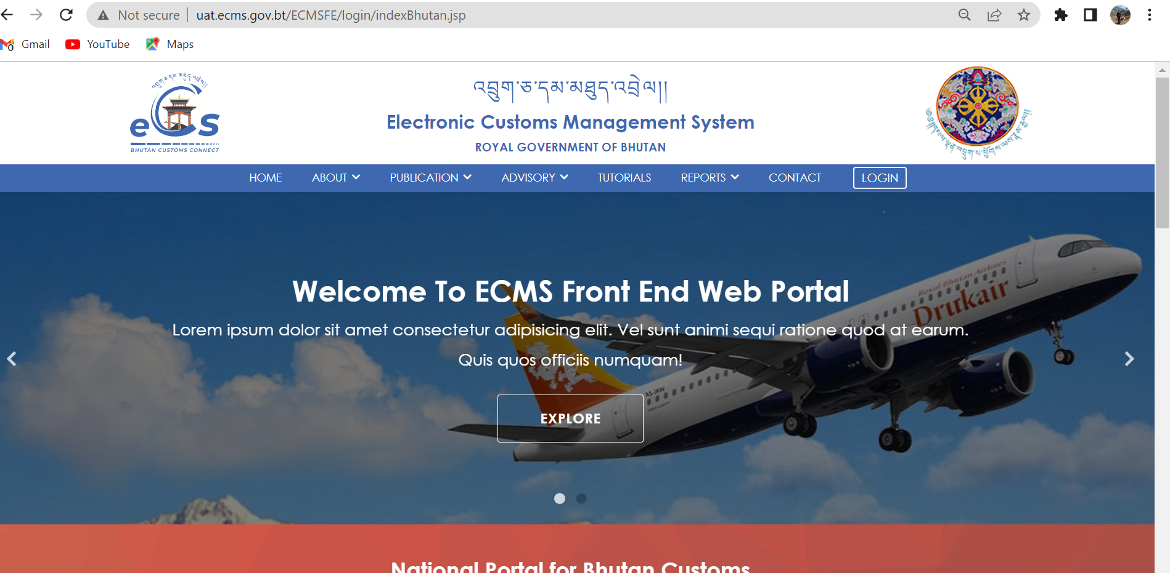

Fig.1. eCMS Landing page
Click>>> LOGIN

  - Click >>LOGIN, the following screen (Figure 2) will be displayed
eCMS Login

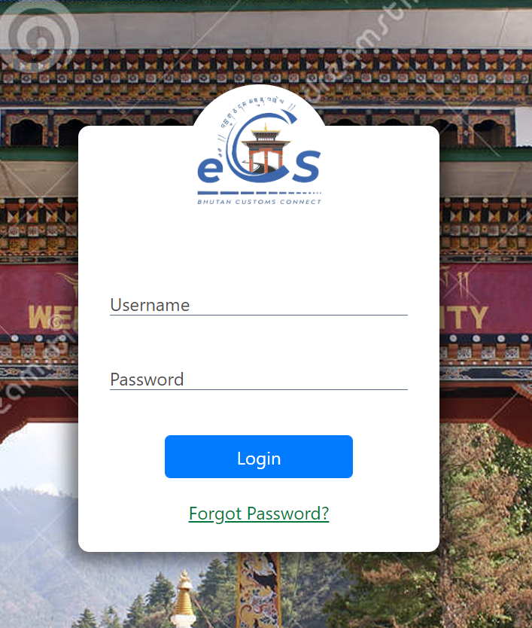
fig.2. eCMS login Page

  - Enter the USERNAME and the PASSWORD in the fields provided and Click button.

@ | In case you need to reset or forgot your password, On the login page, the user clicks the Forgot Password? link to start the process. The new password will be sent to your registered email.

Forgot/Reset password?
- If User Password is expired or forgot , Click >>“Forgot Password?”, “Forgot password Form” is displayed as shown in the figure 3 above.

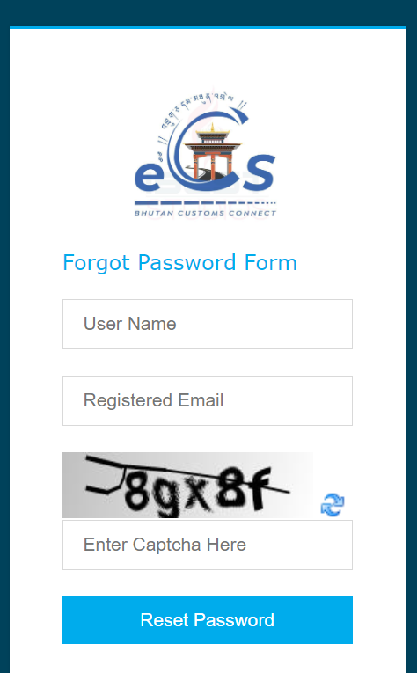
Fig.2. Forgot Password Form.
- Fill in the required details “User Name”, “Registered Email”, “Enter Captcha” and click on “Reset Password” Buttom. The subsequent screen is displayed;
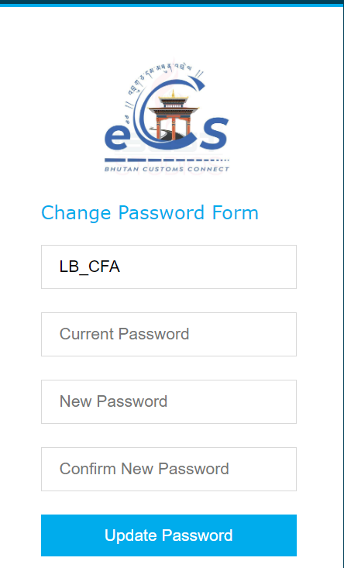
Fig.3. Update password

- Check your email for the password provided by the system and input in “Current Password” Field.
- Set your New Password and Confirm New Password.

- Click >> Update Password, the initial login page is displayed as below;


Fig.4. eCMS Login Page
- Enter the USERNAME and the NEW PASSWORD in the fields provided and Click “LOGIN” button.

Click>> LOGIN

- Upon successful login the Electronic Customs Management System Home Page will be displayed as shown below.
Dashboard Page

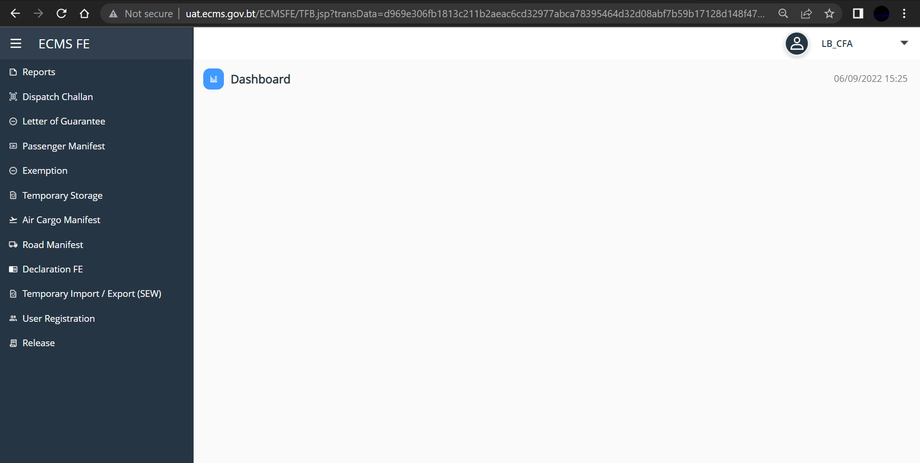
Fig.5. eCMS Dashboard

Chapter 3- DECLARATION.

To Create International Transit Declaration
- Go to Declaration in the menu and click on “Create Declaration”. Subsequent screen is displayed.
- General Information
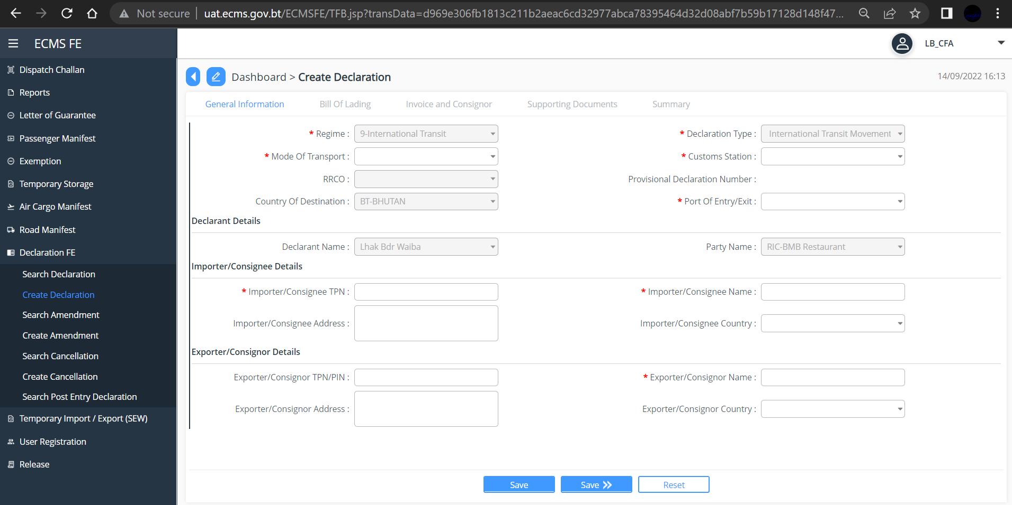
Fig.6. General Information.
- Under Regime, select regime as “International Transit” from the dropdown list
- Under *Declaration Type, select International Transit Movement” and fill in all other mandatory field.
- Click “Save>>” button
@ | Clicking “Save” button will save the information you input. Whereas,  Clicking “>>Save” button will Save the information you input as well as take you to next step.  Clicking “Reset” button will allow the user to reset and input new data.

Click “Save>>”
- Bill of lading
- Click on the “” available on the top right corner of the dashboard to add bill of lading, below screen will be displayed
- Fill in all the mandatory field and Click “Save>>” button
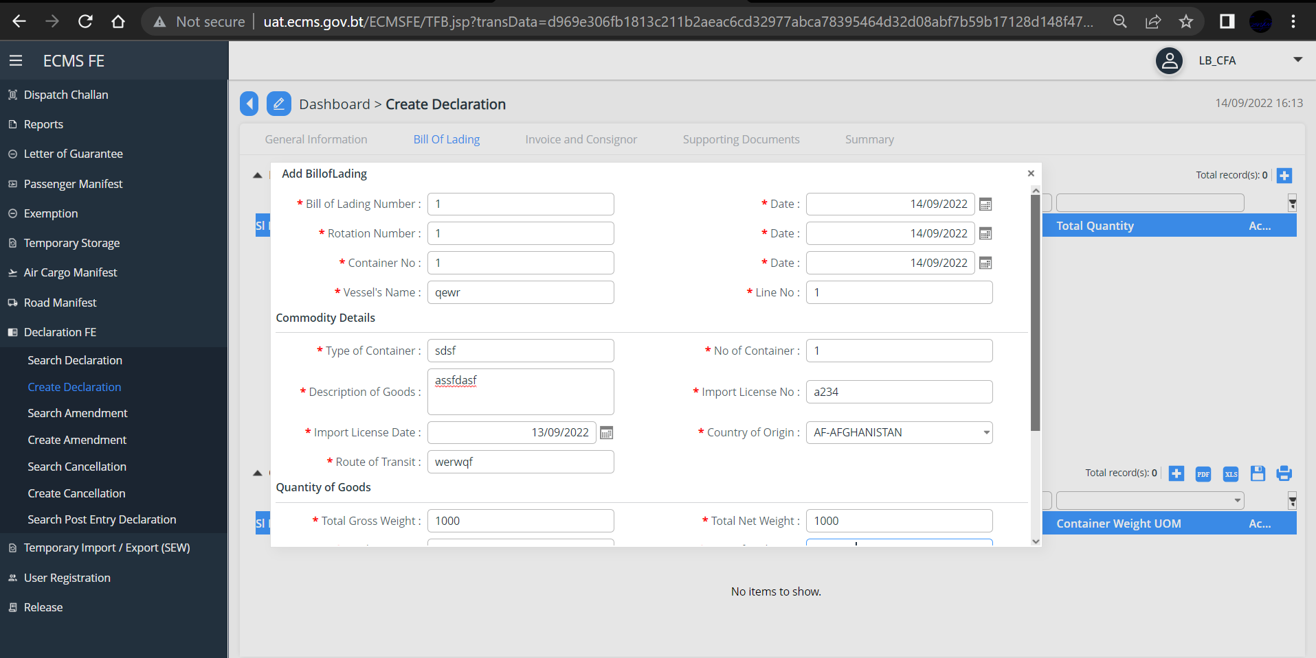
Fig.7. Bill of lading

Click “Save>>”
- Invoice and Consigner
- Fill in all the mandatory field and Click “Save>>” button
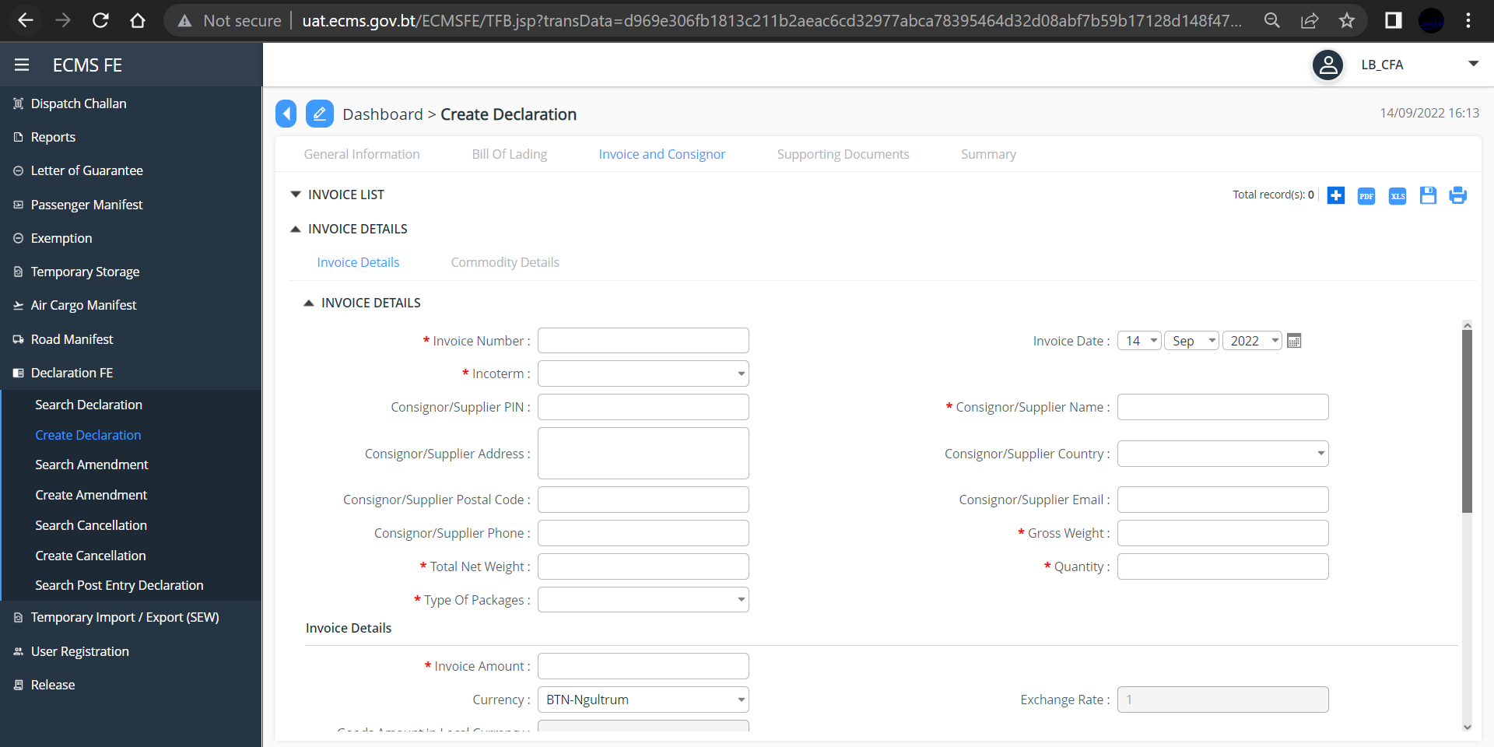
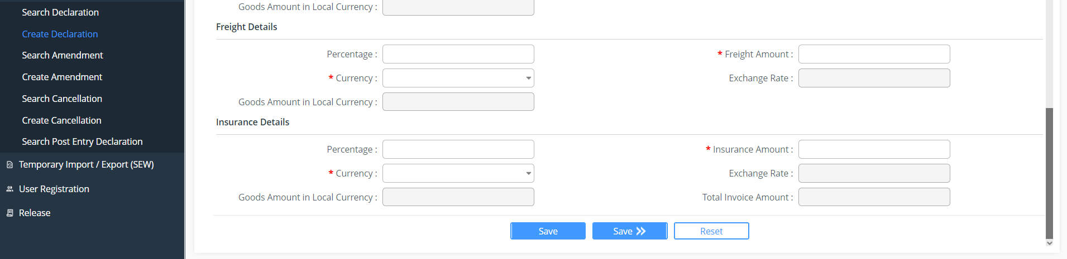
Fig.8. Invoice and Consigner

- Add commodity details and click “Save and compute tax” button
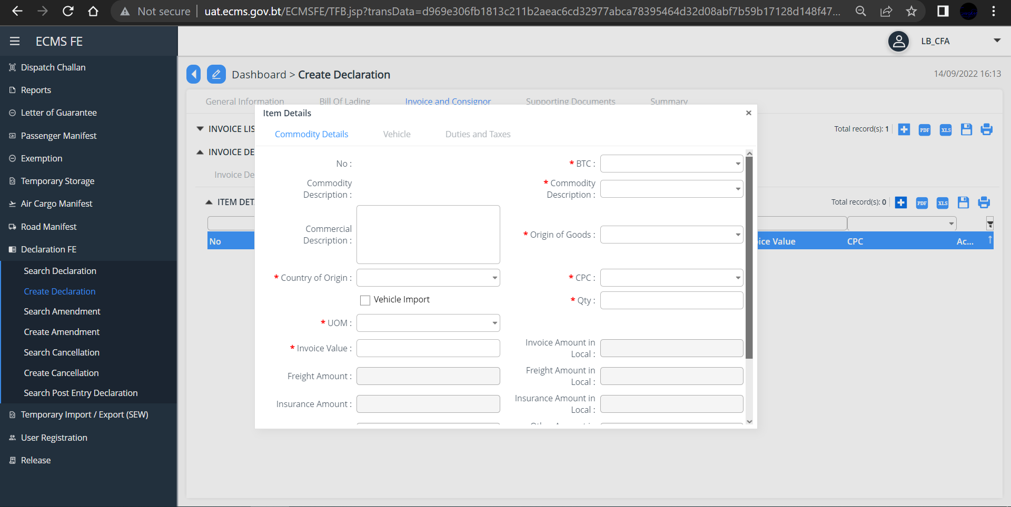
Fig. 9. Commodity details
- Update the vehicle details in the vehicle menu
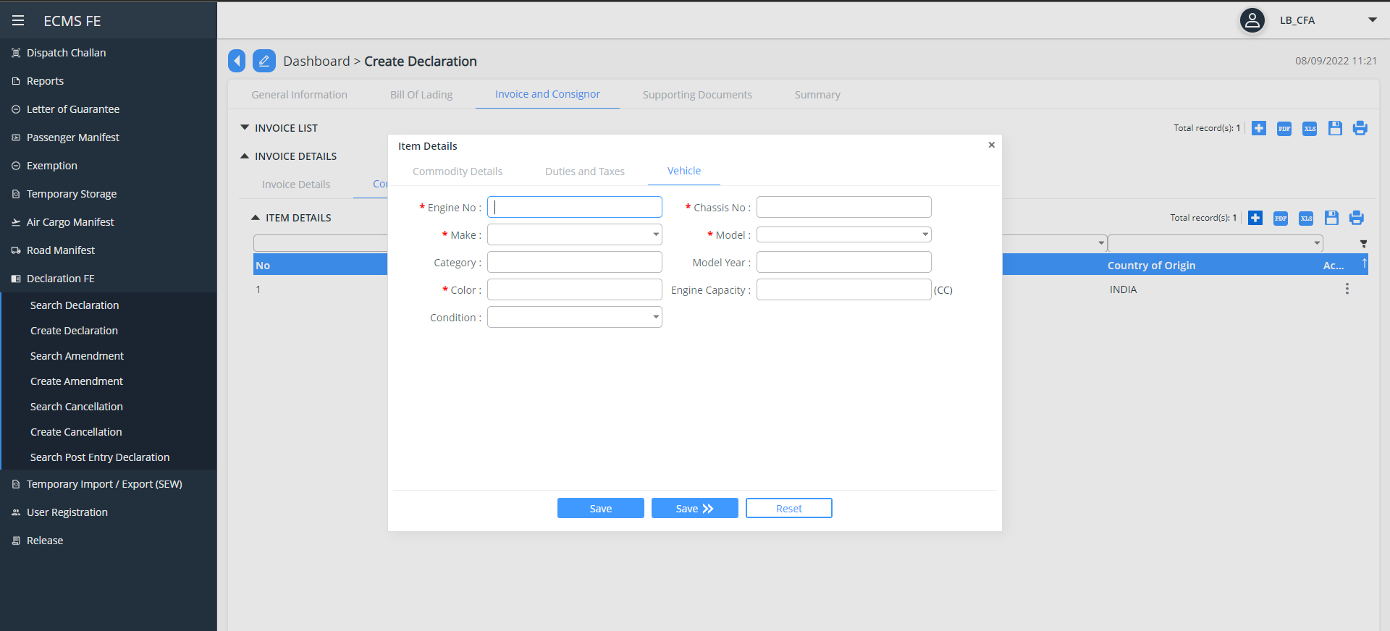
Fig.10. Update Vehicle details
@ | Clicking “Save” button will save the information you input. Whereas,  Clicking “>>Save” button will Save the information you input as well as take you to next step.  Clicking “Reset” button will allow the user to reset and input new data.
- Click “Save>>” Button to save your input and go to next i.e “Supporting Document”
- To add upload your supporting document (invoice), double click on the “invoice” in blue line or click on the three-dot available on extreme right of the invoice and choose and upload the document format in PDF/jpg/jpeg.
- If you have more than one invoice, you can add the by clicking on “” button available on the top right corner of the Dashboard.
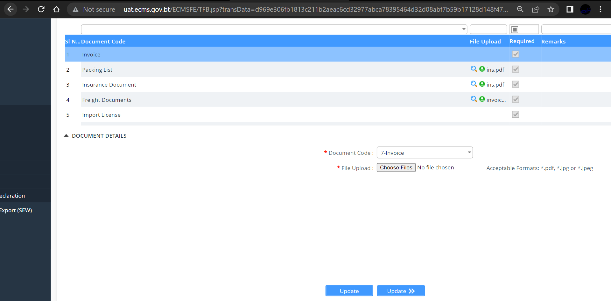Fig. 11. Upload Supporting Document

- Click “Update>>” button, you will reach to “Summary” as shown below.
- Tick on the DISCLAIMER box and click “validate” button to validate your input data
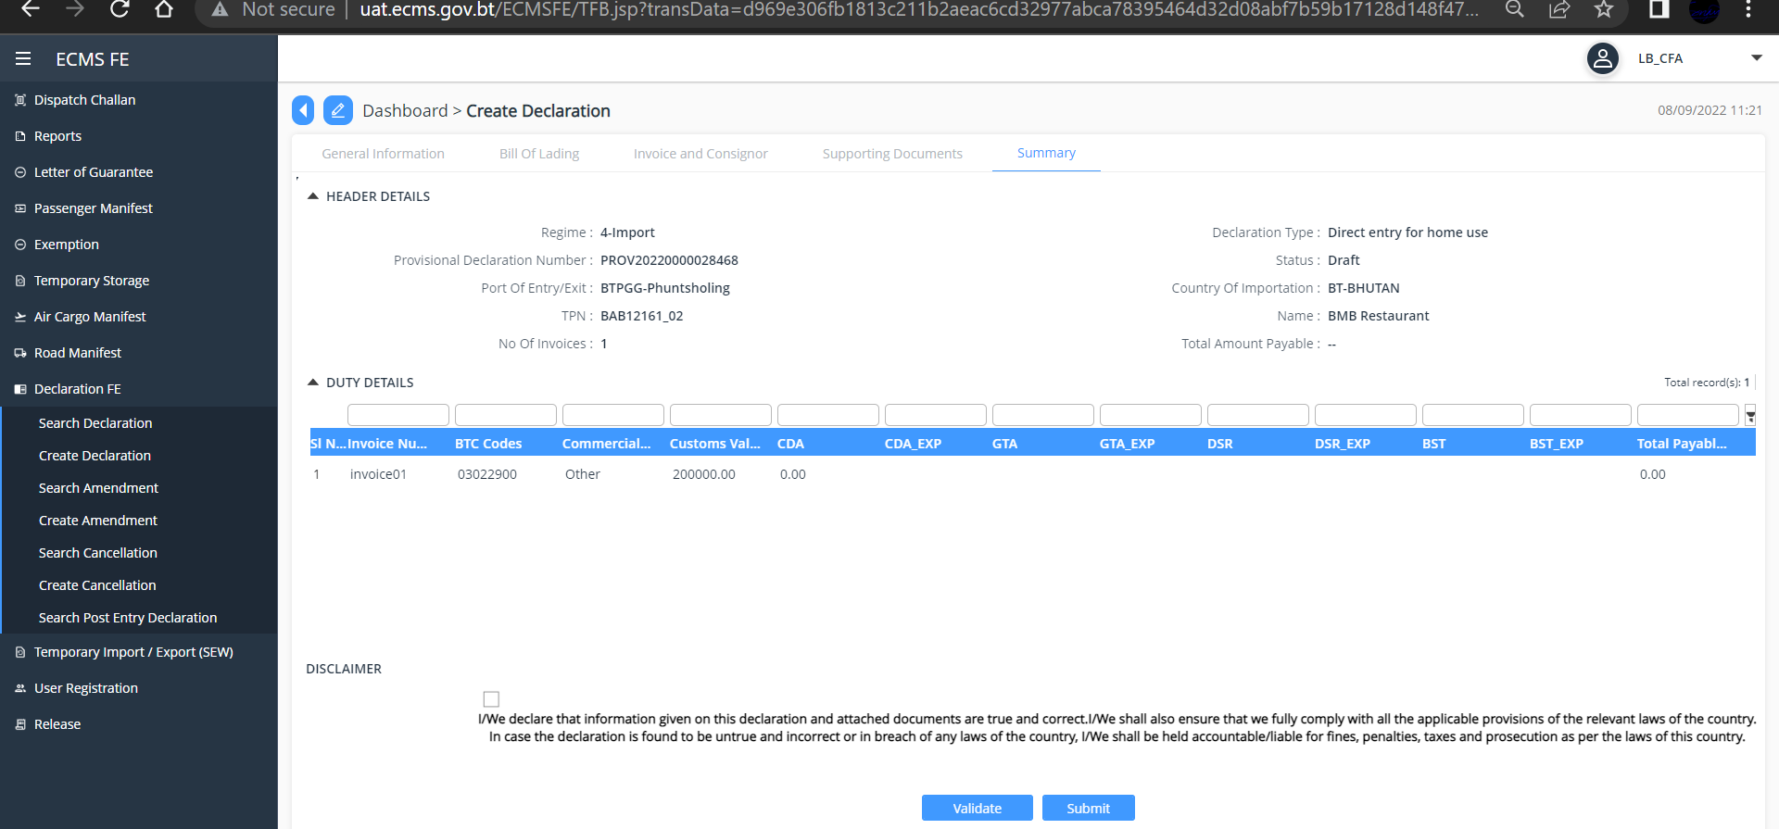
Fig. 12. Validate and Submit Declaration.

- Click “Submit” Button, a successful Declaration Submission Message pops up with the Declaration Number as shown below.
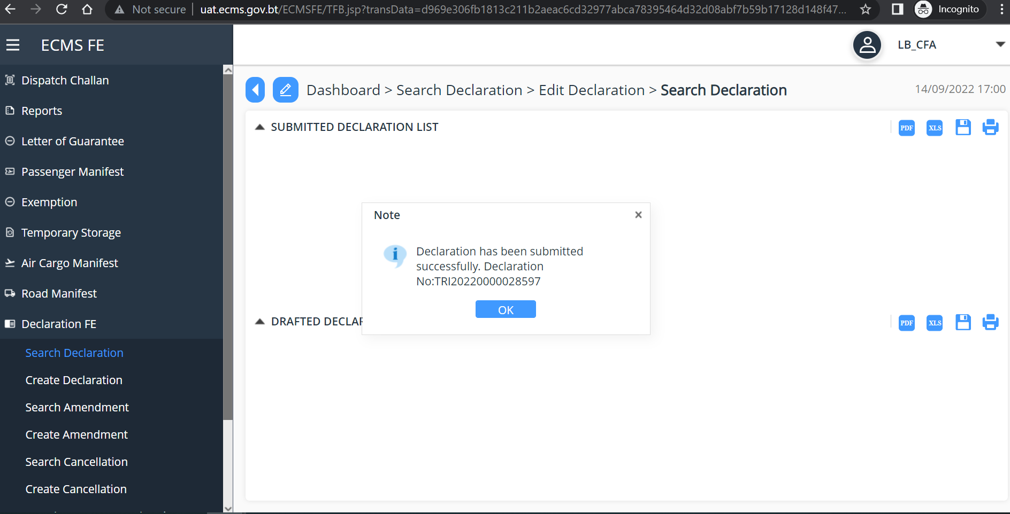
Fig. 13. Submit Declaration Successful Message
@ | After International Transit is approved by the Customs, Letter of Guarantee (LOG) will be Created by the System.

Letter of Guarantee (LOG)
- Go to Letter of Guarantee in the menu and select “Search letter of Guarantee” subsequent screen is displayed.

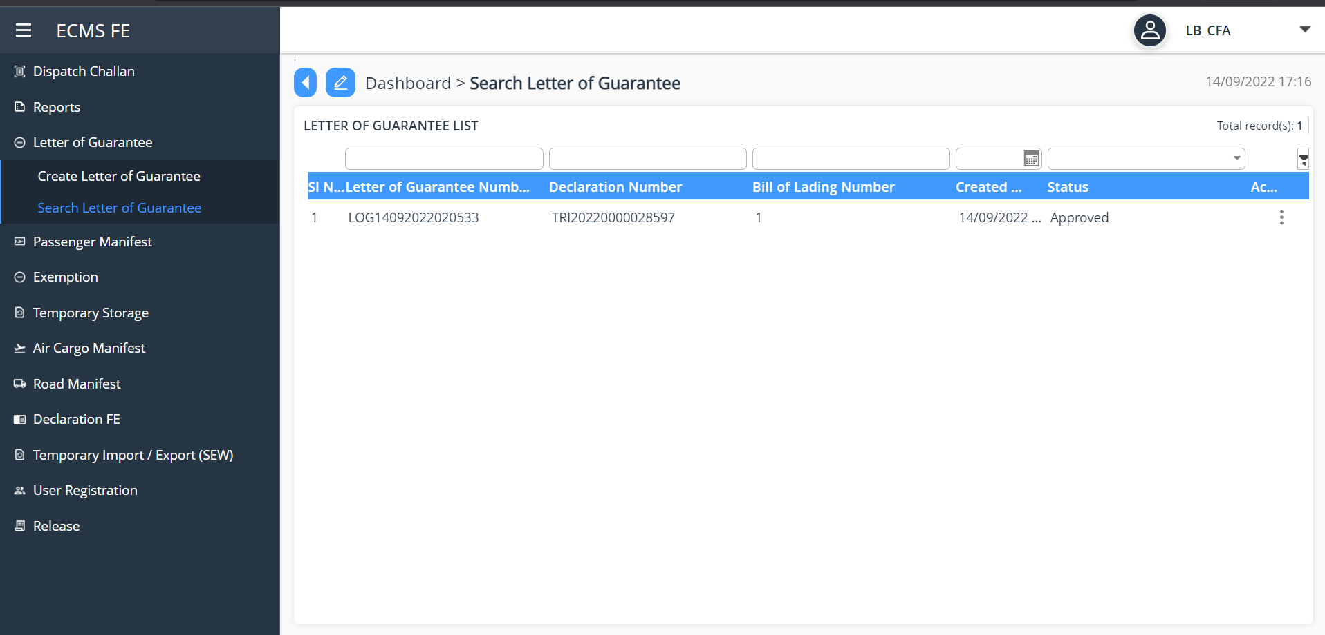
Fig.14. LOG List

- Click on the LOG list to View, Or Click on the three dots available on the extreme right of each LOG list to view, below screen is viewed
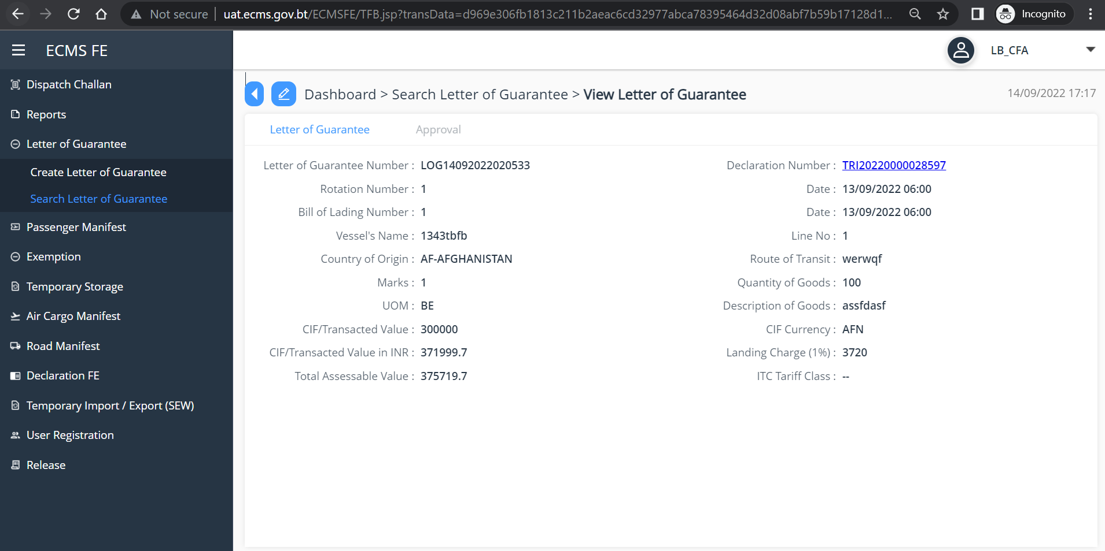
Fig.15. View LOG

@ | LOG number is pulled during the creation of the dispatch challan

Chapter 4-Create Dispatch Challan
- Go to Dispatch Challan in the menu and select “Create Dispatch Challan”. Subsequent Screen is displayed.

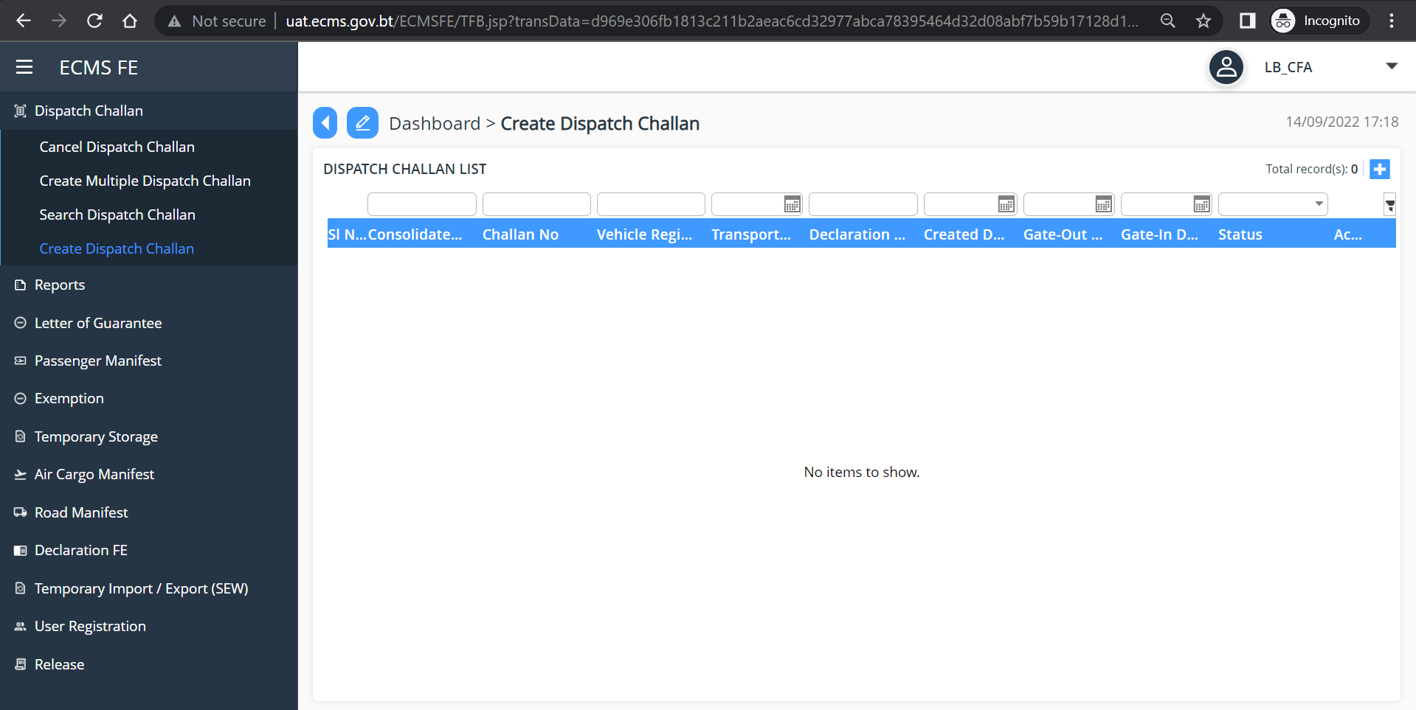
Fig.16. Create Dispatch Challan Dashboard

- Click on the “” button to create your dispatch challan. Below screen is displayed.
- Fill in all the mandatory fields
- In the “Declaration No” select the declaration number from the dropdown list. other information is auto filled including your LOG number.
- Click “Save”

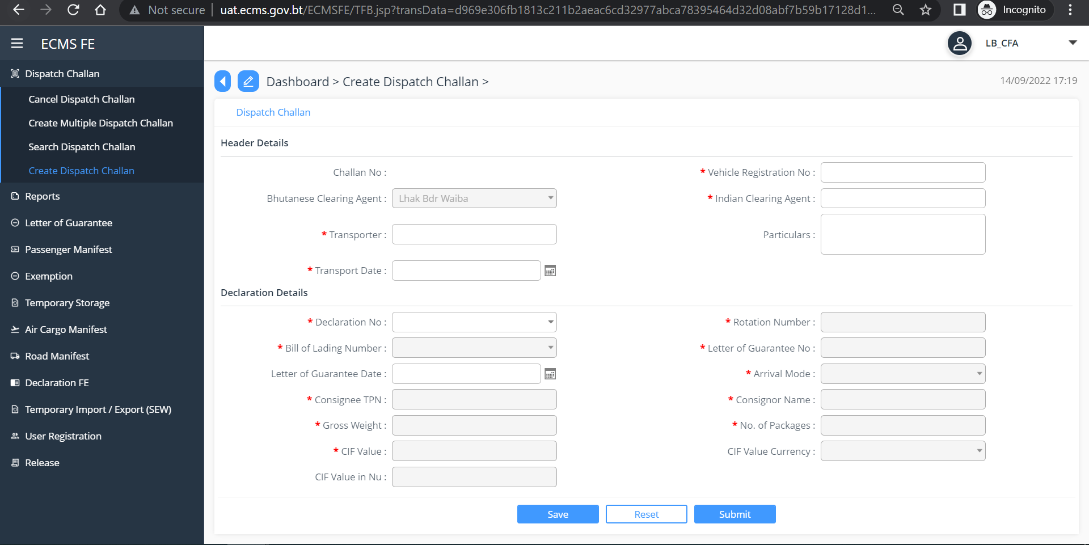
Fig. 17. Create Dispatch Challan Header

- Click “Submit” subsequent screen is displayed.
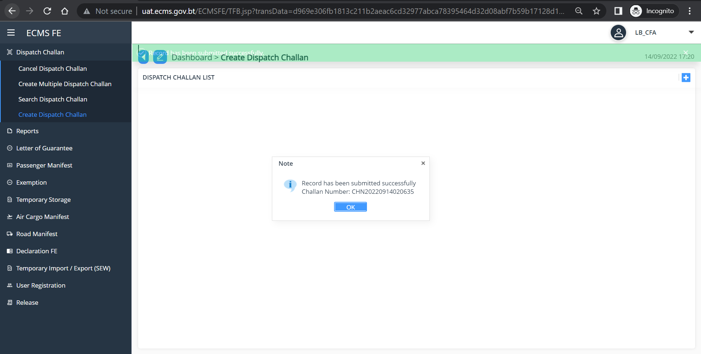
Fig. 18. Dispatch Challan Creation Successful

Chapter 5- Create Declaration

- To create import declaration after International Transit Declaration, Go to Declaration in the Menu and Select “Create Declaration”
- In the Regime, select “Import” from the dropdown list and in the Declaration type, select “Import for home use after International Transit”

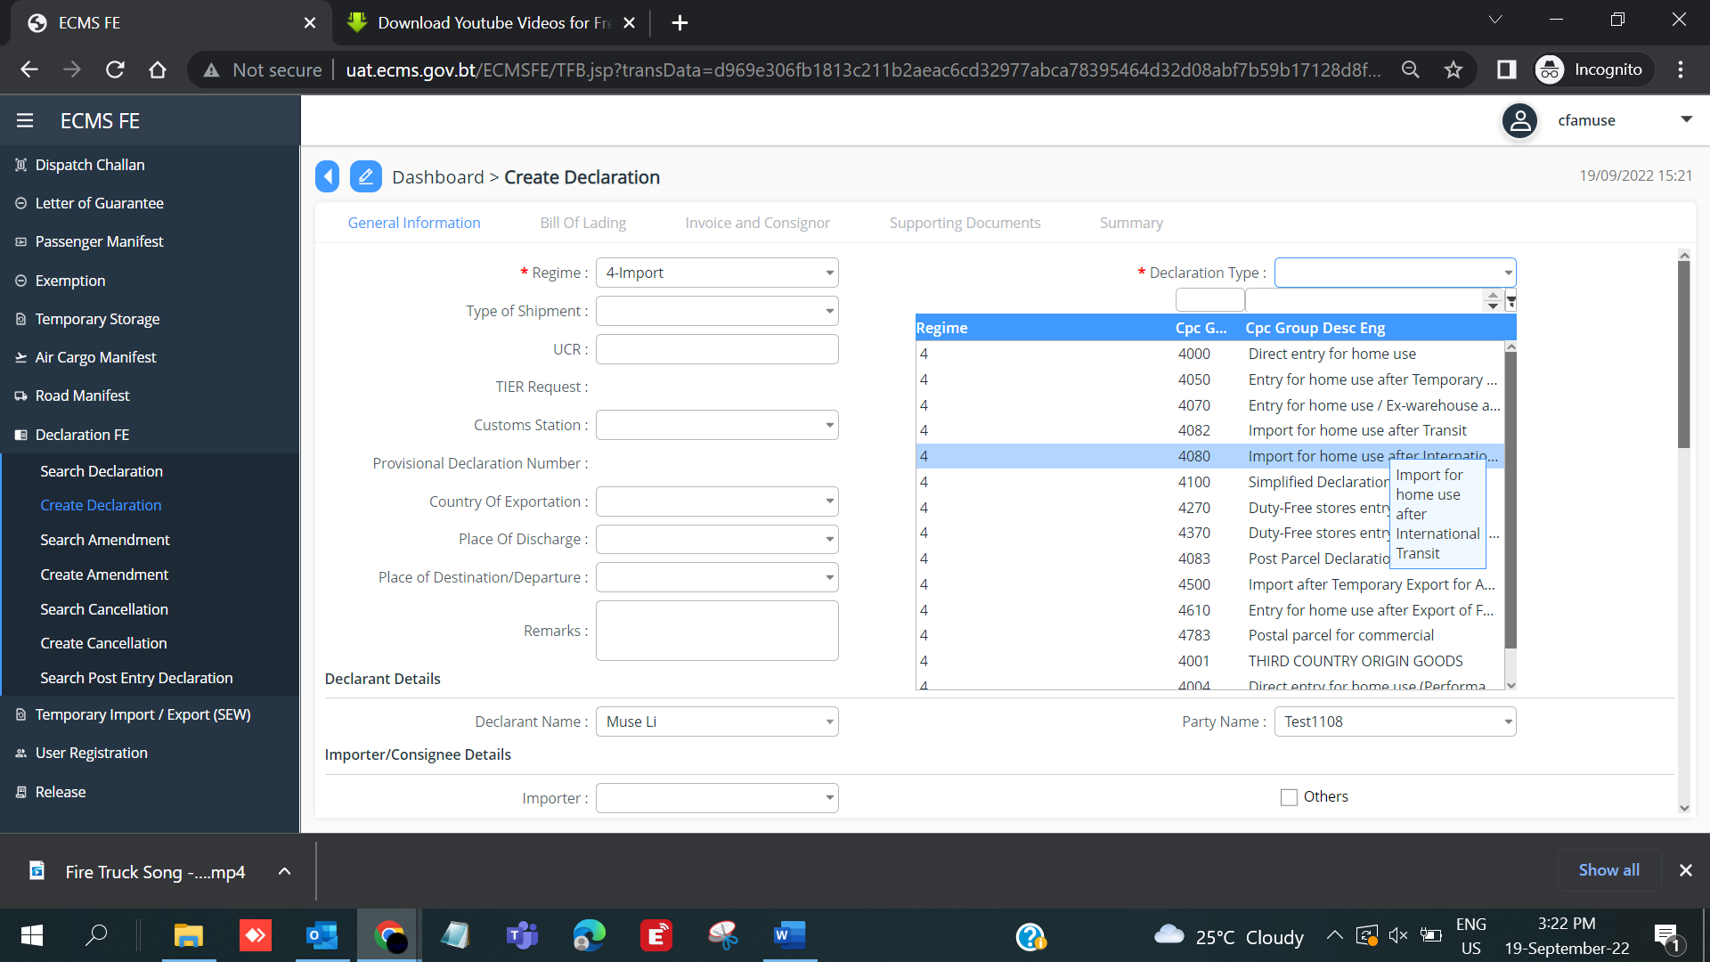
Fig. 19. Create Import Declaration

- Fill the other mandatory field, and in the field “Previous declaration Number” select your declaration number. The rest of the filed will be auto filled as shown below.

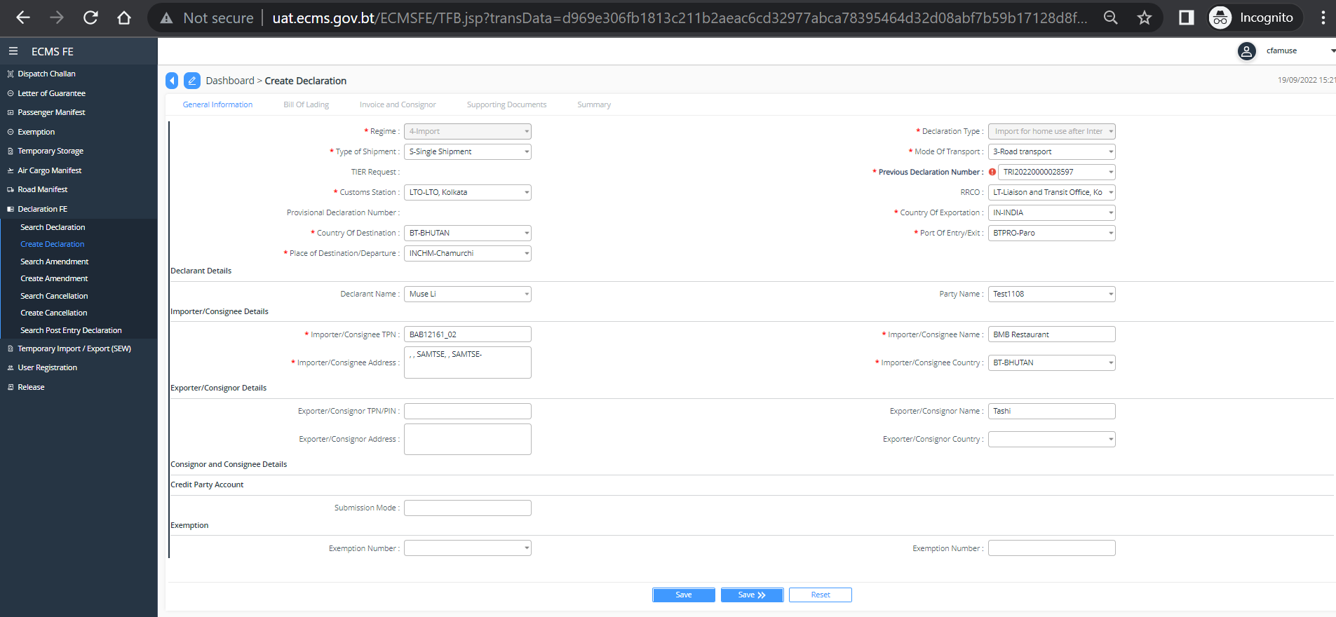
Fig. 20. Import Declaration with previous declaration number
- Click “Save>>”
- Under BILL OF LADING, previous Bill of lading is displayed. check and update the Bill of Lading.
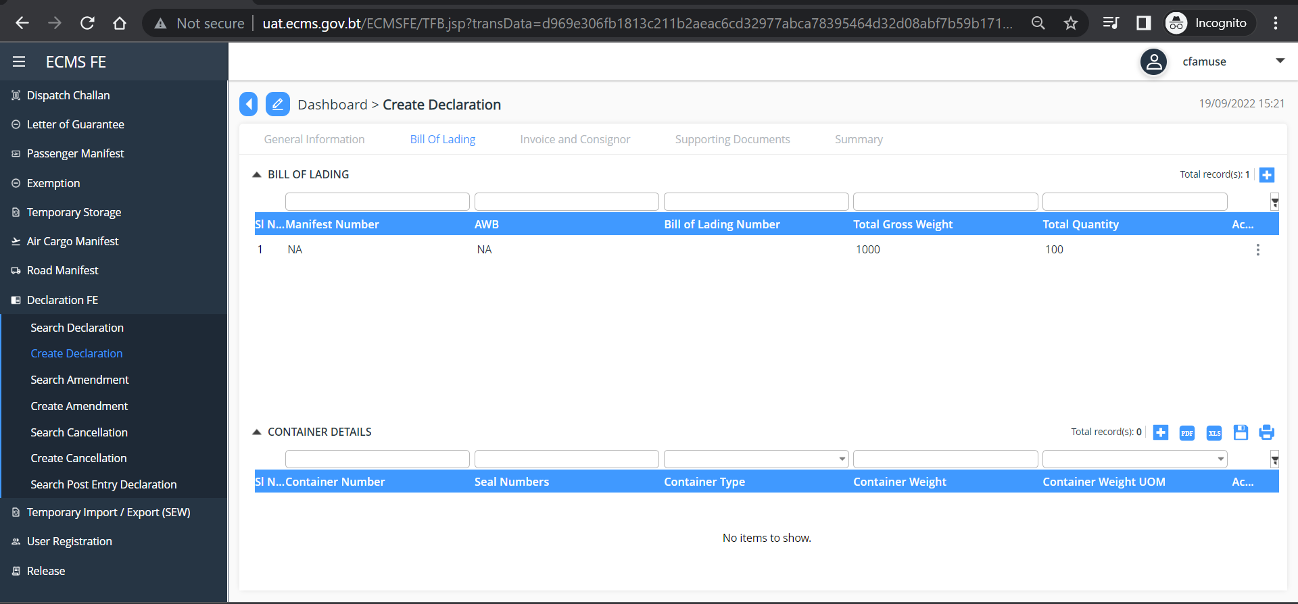
Fig. 21. Bill of Lading

- Under INVOICE AND CONSIGNOR, Previous Bill of lading is displayed. Check and update Invoice and Consignor.
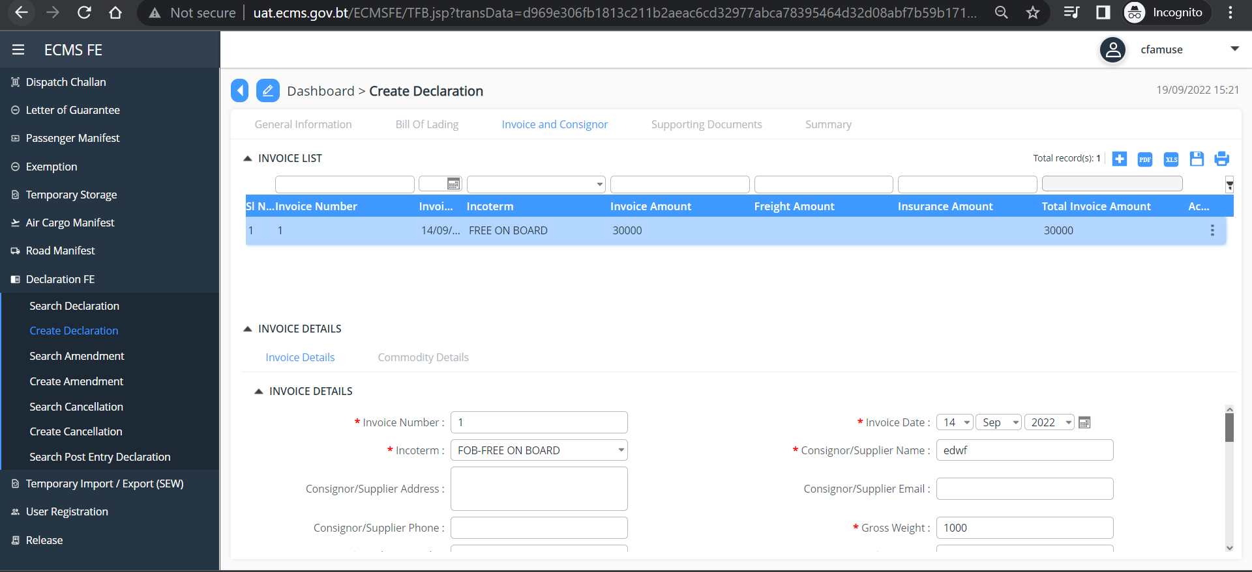

Fig. 22. Invoice and Consignor details

- Check Supporting document as given in subsequent screen. Click on each list to view the list as uploaded previously.

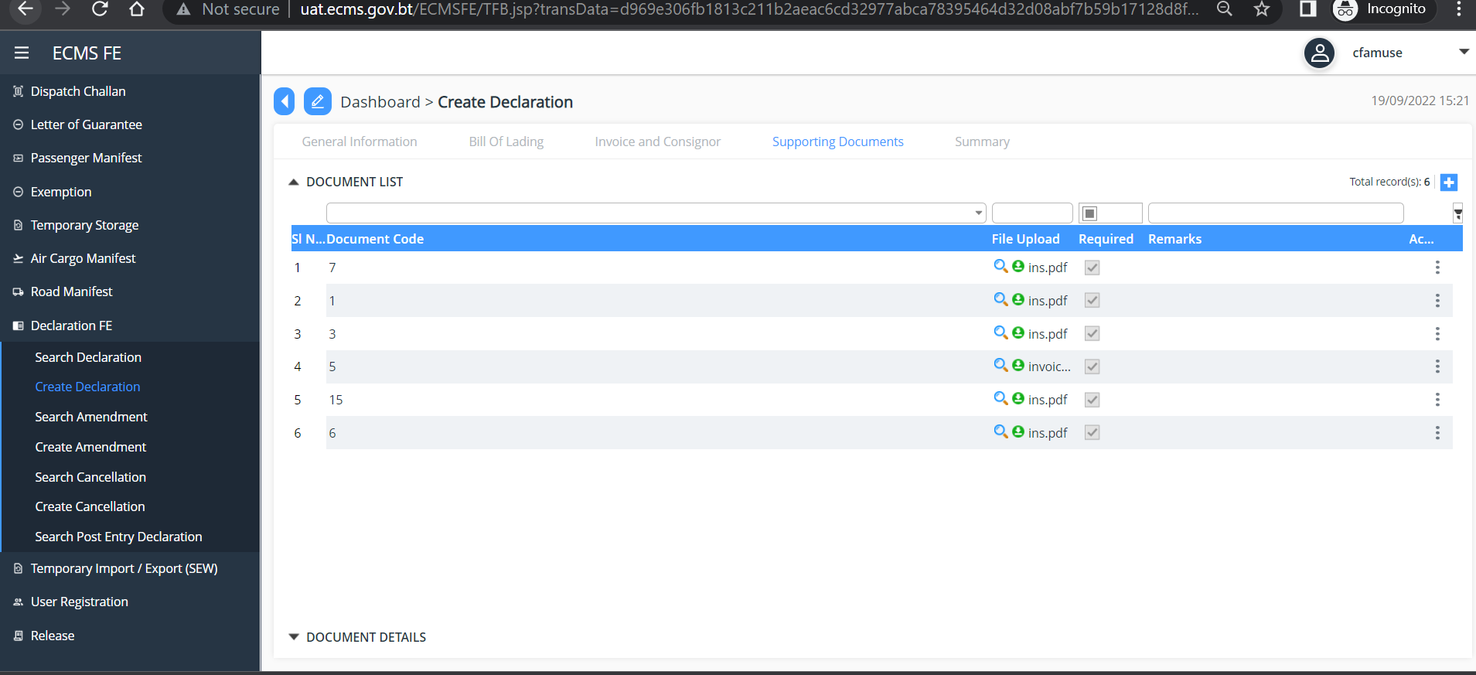
Fig. 23. Supporting Document

Under Summary, validate your declaration and Click “Submit”. Your Declaration will be submitted, and you will be provided declaration number as below.
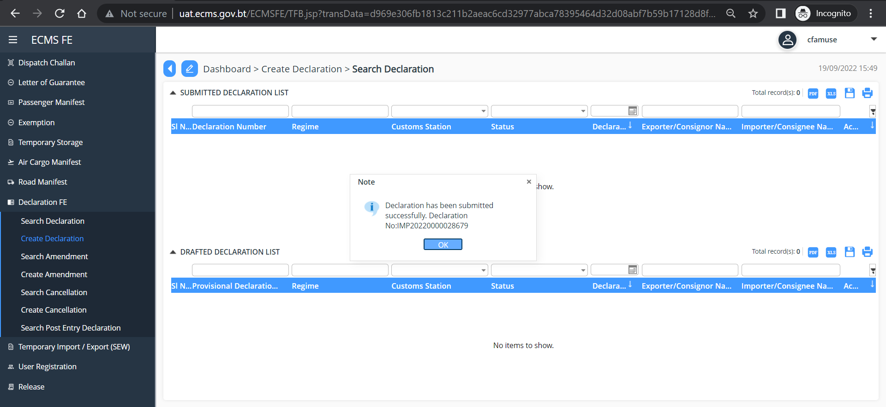
Fig. 24. Declaration Submitted Successfully

Chapter 5- Logging Out

- This function allows the user to log out from the application any time. User can sign out from the eCMS System any time by simply clicking the “Logout” button available in from the dropdown at the upper right corner of the user logged-in window.

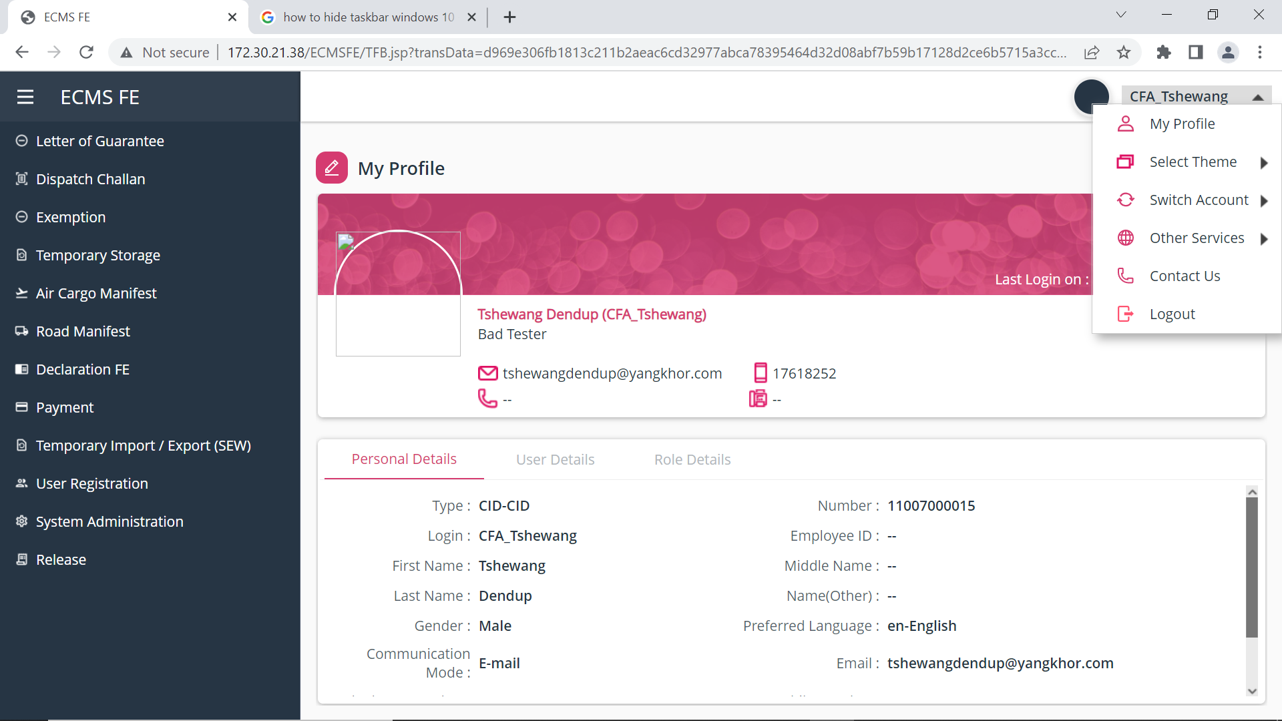
Fig.14. Log Out Page

